**Lab: Controlling playbook execution**

**Introduction:**

**FORKS:** Maximum number of simultaneous connections Ansible made on each Task.

**SERIAL:** Decides the number of nodes process in each task in a single run.

**Objectives:**

Effects of different serial and forks directives on how a play is processed by Ansible.

Log in to **ansi-master** as **root** user and password as **linux.**

1. Change to the .**/parallelism** directory.

# cd

# mkdir parallelism

# cd parallelism

* 1. Examine the contents of the **ansible.cfg file**. Note that the inventory file is set to inventory. Note also that the **forks parameter** is set to **4.**

# cat > ansible.cfg <<EOF

[defaults]

inventory = ./inventory

forks=4

[privilege_escalation]

become=true

become_method=sudo

become_user=root

become_ask_pass=false

EOF

**1.2** Examine the contents of the inventory file. Note that it contains a host group, **webservers**, which contains **three hosts**.

$ cat > inventory << EOF

[webservers]

ansi-node1

ansi-node2

ansi-node3

EOF

**1.3** Lets create **playbook.yml** file. The playbook executes on the webservers host group, ensures that the latest **httpd package** is installed and that the httpd service is enabled and started.

$ cat > playbook.yml <<EOF

---

- name: Update web server

hosts: webservers

become: yes

tasks:

- name: Latest httpd package installed

dnf:

name: httpd

state: latest

notify:

- Restart httpd

handlers:

- name: Restart httpd

service:

name: httpd

enabled: yes

state: restarted

EOF

**1.4** Finally examine the contents of the **remove_apache.yml** file. The playbook executes on the webservers host group, ensures that the httpd service is **disabled** and **stopped**, and then ensures that the httpd package is not installed.

$ cat > removeapache.yml << EOF

---

- hosts: webservers

tasks:

- service:

name: httpd

enabled: no

state: stopped

- dnf:

name: httpd

state: absent

EOF

**2.** Let’sExecute the **playbook.yml** playbook using **time** command to determine how long it takes for the playbook to run. Watch the playbook as it runs. Note how ansible performs each task on all three hosts at the same time.

$ time ansible-playbook playbook.yml

**Output**:

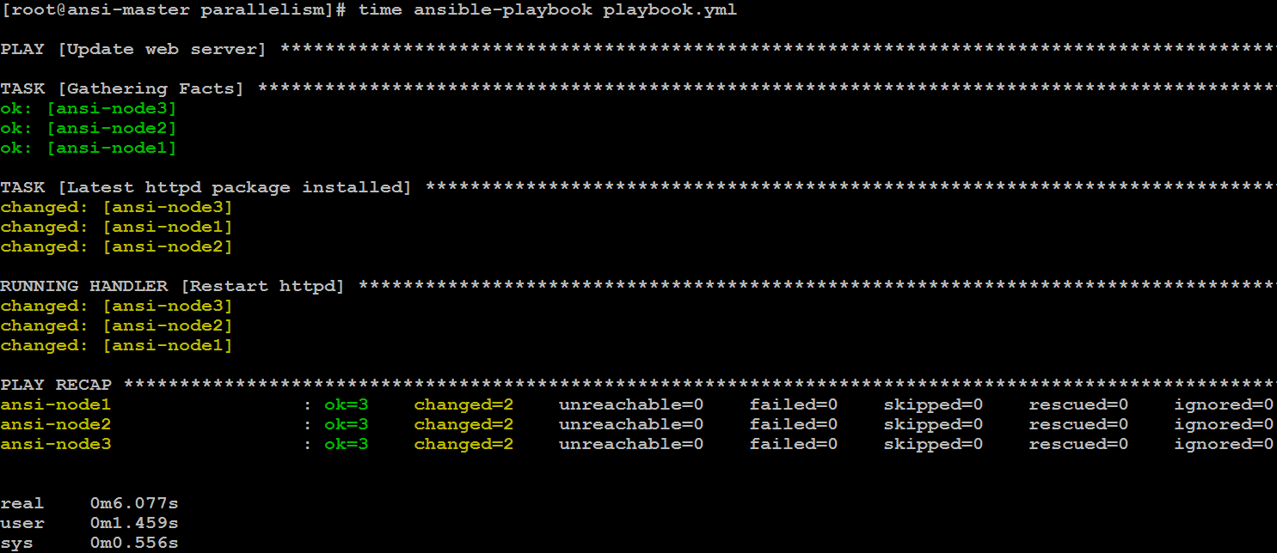

**3.** Execute the **remove_apache.yml** playbook to stop and disable the httpd service and to remove the httpd package.

# time ansible-playbook removeapache.yml

**Output**:

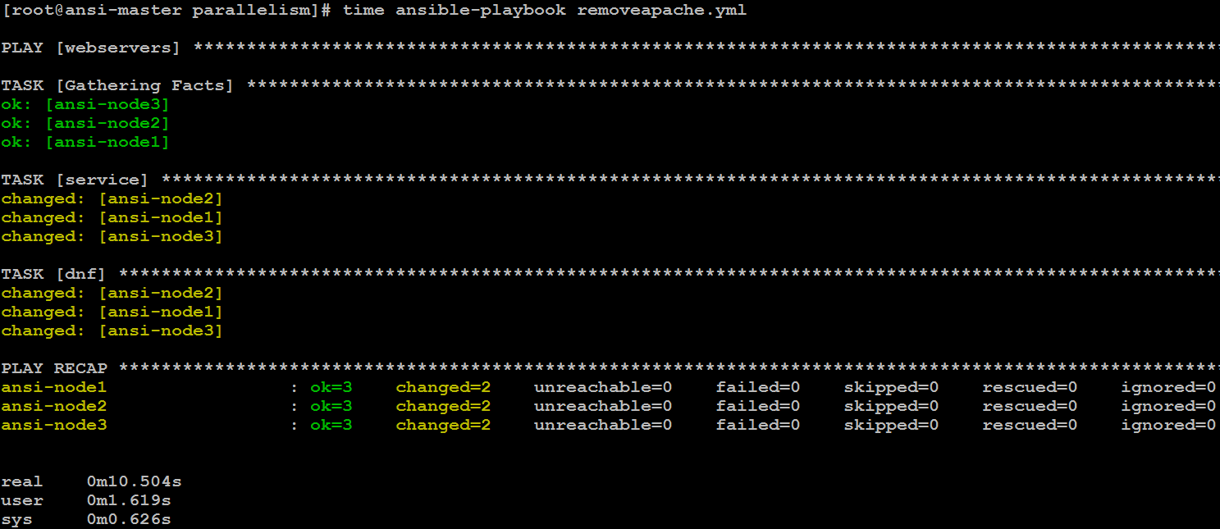

**4.** Change the value of the **fork parameter** to **1** in **ansible.cfg.**

# cat > ansible.cfg <<EOF

[defaults]

inventory = ./inventory

forks=1

[privilege_escalation]

become=true

become_method=sudo

become_user=root

become_ask_pass=false

EOF

**5**. **Re-execute** the **playbook.yml** playbook using time command to determine how long it takes for the playbook to run.

# time ansible-playbook playbook.yml

Output:

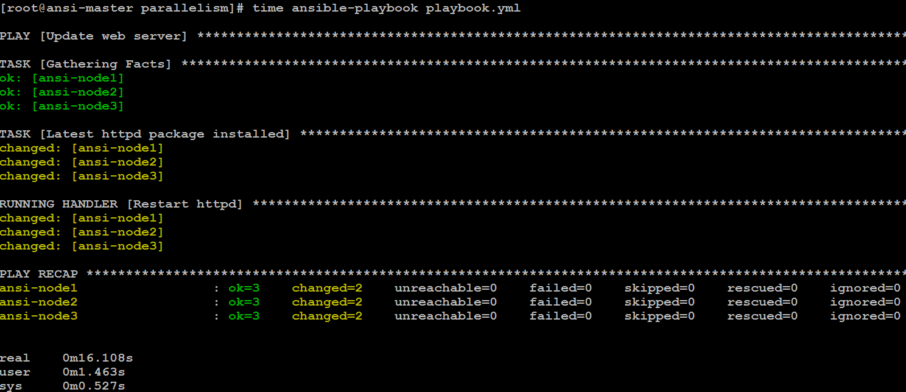

**6.** Execute the **remove_apache.yml** playbook to stop and disable the httpd service and to remove the httpd package.

# time ansible-playbook removeapache.yml

Output:

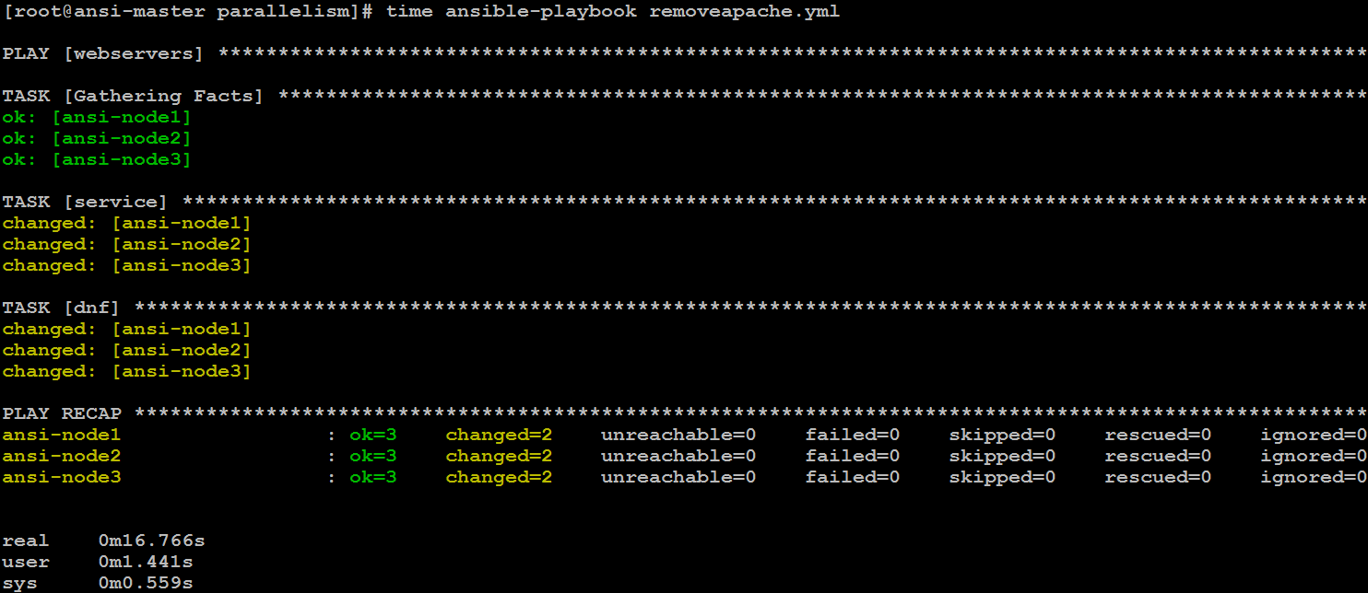

**7.** Set the value of the **forks parameter** to **2** in **ansible.cfg.**

# cat > ansible.cfg <<EOF

[defaults]

inventory = ./inventory

forks=2

[privilege_escalation]

become=true

become_method=sudo

become_user=root

become_ask_pass=false

EOF

**8.** Add the following serial parameter to the play in the playbook.yml playbook so that the play only executes on two hosts at a time.

# cat > playbook.yml <<EOF

---

- name: Update web server

hosts: webservers

serial: 1

tasks:

- name: Latest httpd package installed

dnf:

name: httpd

state: latest

notify:

- Restart httpd

handlers:

- name: Restart httpd

service:

name: httpd

enabled: yes

state: restarted

EOF

**9.** Re-execute the playbook.yml playbook. Watch the playbook as it runs. Note how Ansible executes the entire play on just two hosts before re-executing the play on the two remaining hosts.

# time ansible-playbook playbook.yml

Output:

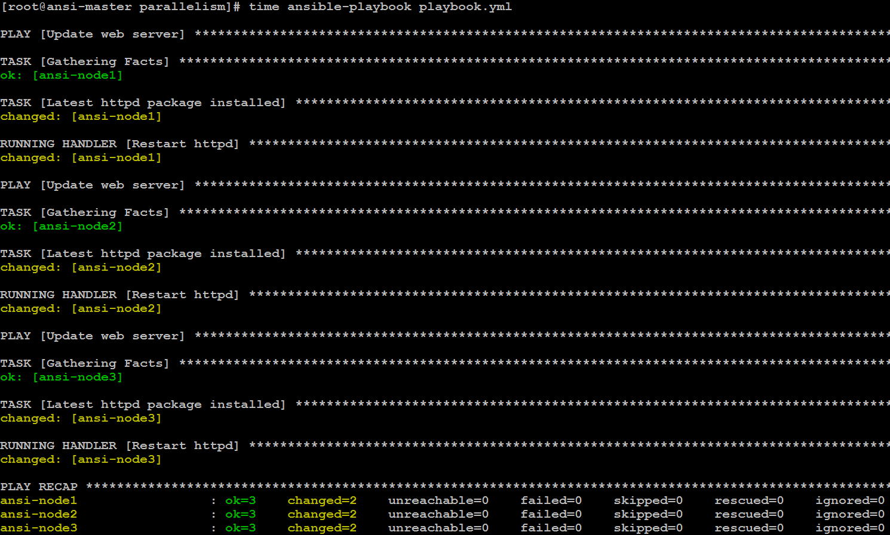

**10**. Execute the remove_apache.yml playbook to stop and disable the httpd service and to remove the httpd package.

$ time ansible-playbook removeapache.yml -i inventory

Output:

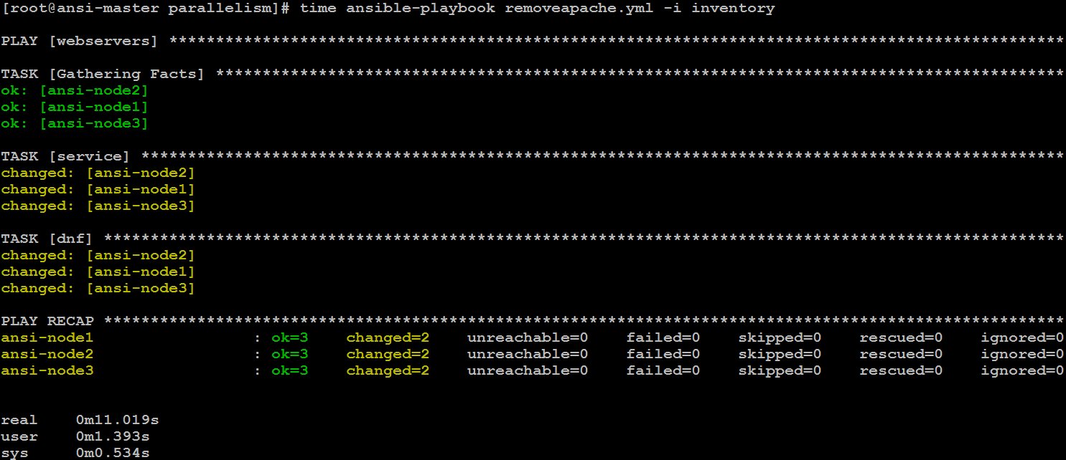

**11**. Set the value of the **forks** parameter back to **4** in **ansible.cfg.**

$ cat > ansible.cfg <<EOF

[defaults]

inventory = ./inventory

forks=4

[privilege_escalation]

become=true

become_method=sudo

become_user=root

become_ask_pass=false

EOF

**12.** Set the serial parameter in the playbook.yml playbook to 3.

# cat > playbook.yml <<EOF

---

- name: Update web server

hosts: webservers

serial: 3

tasks:

- name: Latest httpd package installed

dnf:

name: httpd

state: latest

notify:

- Restart httpd

handlers:

- name: Restart httpd

service:

name: httpd

enabled: yes

state: restarted

EOF

**13.** Re-execute the playbook.yml playbook. Ansible executes the entire play on just three hosts and then re-executes the play on the one remaining host.

$ time ansible-playbook playbook.yml -i inventory

Output:

